CHESHIRE WEST AND CHESTER COUNCIL
REVIEW OF COMMUNITY GOVERNANCE ARRANGEMENTS
FRODSHAM TOWN COUNCIL – REVIEW OF THE NUMBER OF TOWN COUNCILLORS
The consultation will run from 26 January – 13 March 2026

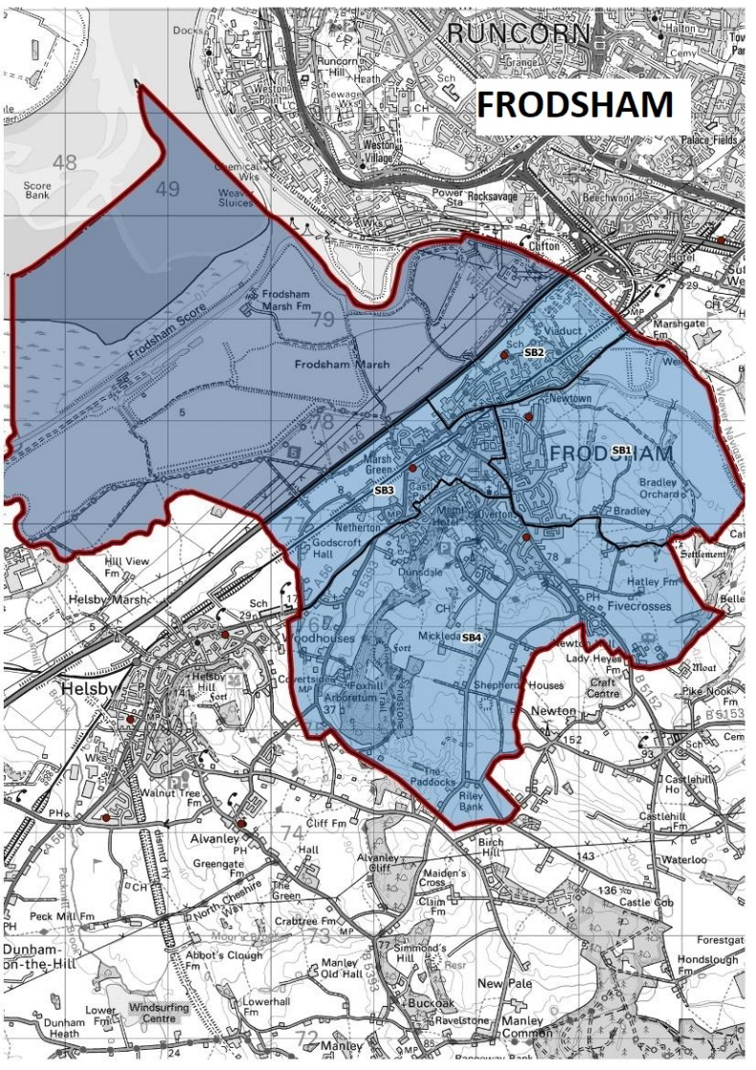

Contact Democratic Services:  democraticservices@cheshirewestandchester.gov.uk  01244 977076 | 


COMMUNITY GOVERNANCE REVIEW OF FRODSHAM TOWN COUNCIL MEMBERSHIP

- Do you associate yourself with Frodsham Town?

- Yes
- No
- Not sure
- Additional comments

2 If you answered yes to question 1, in what way do you associate with Frodsham Town? Please explain:

- Town Councils are local authorities found in England and they are the lowest tier of local government operating in a geographical area known as civil parishes. Frodsham Town Council currently has seats for 16 Town Councillors. The Town Council meets regularly to resolve local issues and make decision on behalf the people in the Town of Frodsham. However, it is currently carrying several vacancies as it has been unable to fill all 16 seats.

Please can you confirm if you have you ever engaged with Frodsham Town Council?

- Yes
- No
- Not sure
- Additional comments

- If you answered yes to question 3, were you happy with how your matter was dealt with/resolved?
- Yes
- No
- Not sure
- Additional comments

- Do you feel that you have an adequate say in local issues in Frodsham and how local services are delivered?

- Yes
- No
- Not sure

- Additional comments

- Question 7 below lists some examples of where local issues can be raised or where you may be able to have your say on local matters. Have you ever engaged with any of the below or other arrangements regarding any local issues?

- Yes
- No
- Not sure
- Additional comments

7 If you answered yes to question 6, please indicate which ones you have engaged with:
- Direct with Cheshire West and Chester Council
- Ward Councillor
- Local Area Committee
- MP
- Residents Association
- Bespoke community organisations
- Housing Tenant Associations
- Churches
- Other, please specify:

8 If you answered yes to question 6, please can you confirm how satisfied you were with the engagement and response which you received?
- Very Satisfied
- Satisfied
- Neither satisfied or dissatisfied
- Somewhat dissatisfied
- Very dissatisfied

- As Frodsham Town Council has been carrying a number of vacancies for some time, it would like to reduce its current membership from 16 to 12. Would you be happy for this reduction to take place?

- Yes
- No
- Not sure
- Additional comments

10 If you have answered no to question 9, please can you identify why you answered no and what suggestions you may have for how Frodsham Town Council can fill its current vacancies?

Please use this free text box below for any additional information you would like to provide

ABOUT YOU
The information provided on this questionnaire and below will be kept and stored confidentially and not shared with any third party or interested parties. All the information provided will be used for the purposes of this Community Governance Review only.
The below information will allow us to look at viewpoints provided from different geographic areas. Please be assured that this will not allow us to identify individual people.

- What is your house number or name?
- What is your street name?

- What is your postcode?

Which of the following best describes you?
- A current resident of Frodsham
- A stakeholder who has an interest in the local area
  - If so what?

- Other (please state)

If you can, please provide a valid email address which can be used for consultation number two and three. This email address will not be shared with any third party or interested parties.



